AWS THREE TIER ARCHITECTURE
- A Three tier Architecture is a well-structured way to build scalable, secure, and manageable applications by dividing them into three layers.

- Web-Tier (Frontend): The Web tier is the user interface and communication layer of the application, where the end user interacts with the application. Its main purpose is to display information to and collect information from the user. This top-level tier can run on a web browser, as desktop application, or a graphical user interface (GUI). Web presentation tiers are developed by using HTML, CSS, and JavaScript. Desktop applications can be written in various languages depending on the platform.

- Application-Tier (Business Logic): The application tier, also known as the logic tier or middle tier, is the heart of the application. The application tier is typically developed by using Python, Java, Perl, PHP or Ruby, and communicates with the data tier by using API calls.

- Data-Tier (Data Storage): The data tier, sometimes called database tier, data access tier or back-end, is where the information that is processed by the application is stored and managed. This can be a relational database management system as PostgresSQL, MySQL,MariaDB.

- In this Three-tier architecture project we have used several AWS services and resources which has been illustrated by below architecture.
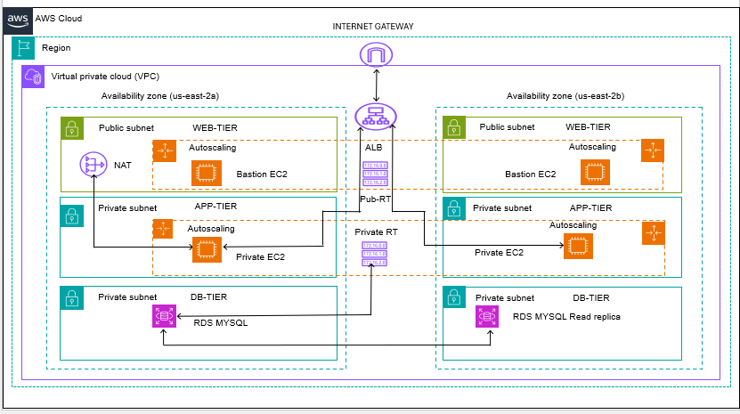
EXPLANATION
- In AWS cloud and Ohio (us-east-2) region we have created Virtual private network (VPC) and Internet gateway and have attached to the created VPC.
- After creation of VPC, we have created two public subnets and two private subnets with public Route table and private Route table.
- Created a Nat gateway in the public subnet so that EC2 instances in private subnet will be able to access internet.
- Configure the Public Route Table and Private Route Table and associate the subnets accordingly.
- Created an application load balancer which will be able to distribute traffic among the healthy private instance by using autoscaling service to ensure high scalability and high available.
- The information processed by application will be stored in Database tier in private subnet which ensures security and at the same time the read replicas will be also used to offload read related queries that makes primary DB instance work more efficiently.
STEP 1: Create a VPC and internet gateway in us-east-2 region and attach the Internet gateway to the VPC.
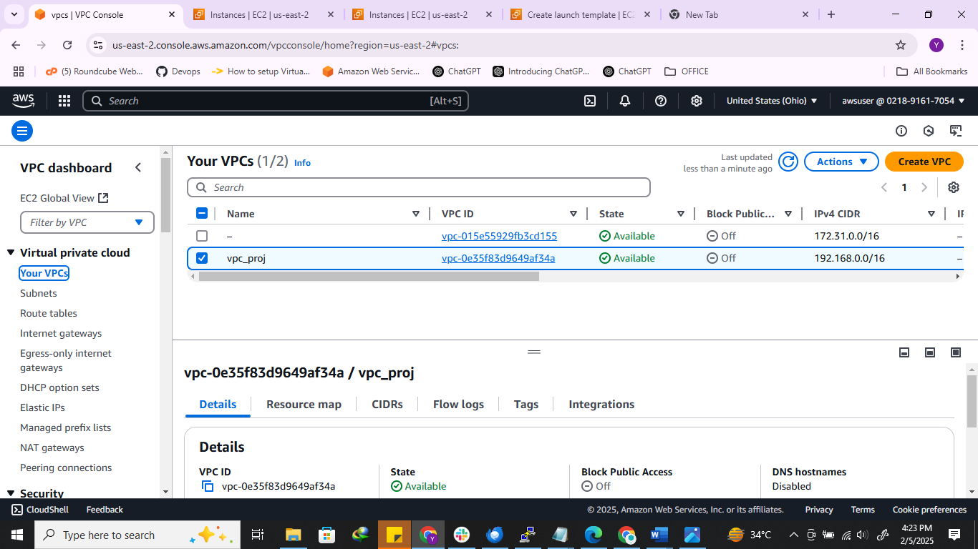

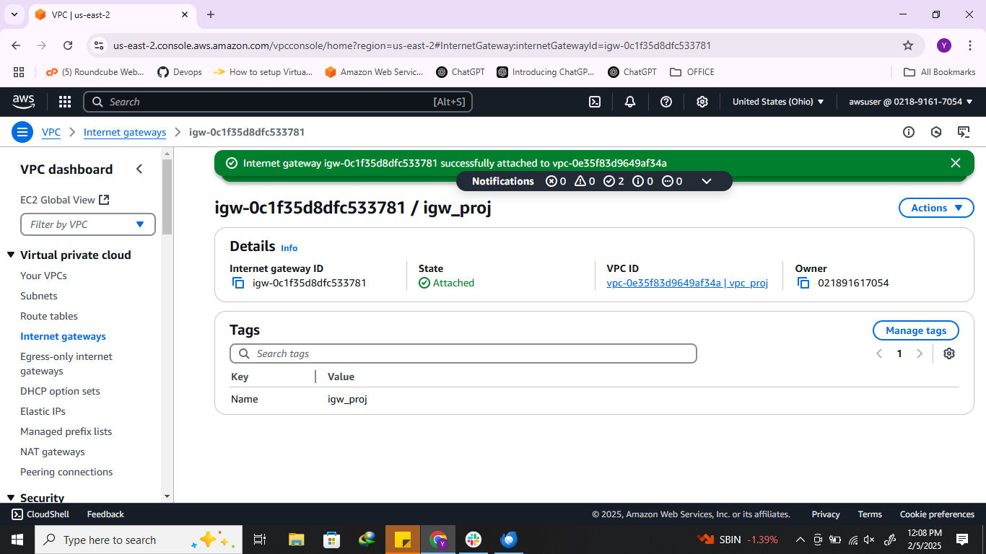

STEP 2: Create two public subnets and two private subnets in different availability zone in us-east region. After that create Public route tables and Private tables.
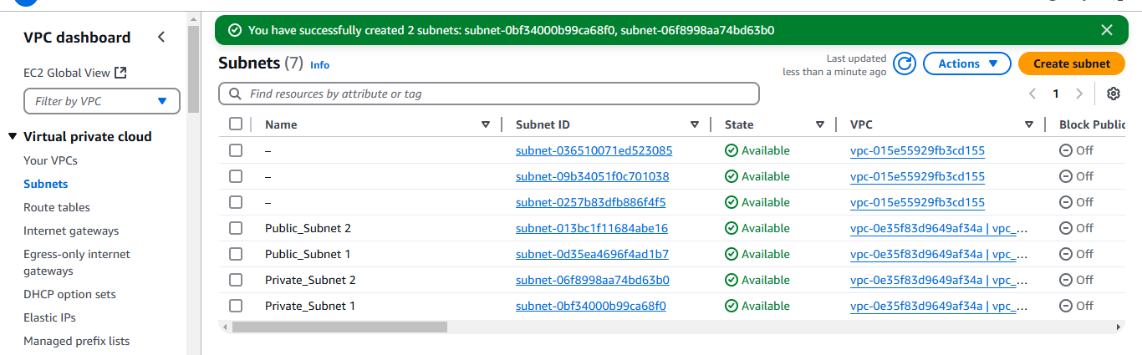

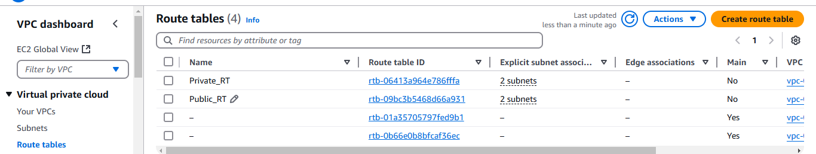

STEP 3: Create a NAT gateway in public subnet and configure the public and private route tables in such a way that traffic will route to Internet gateway and NAT gateway respectively.
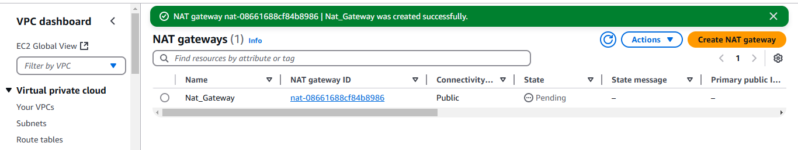

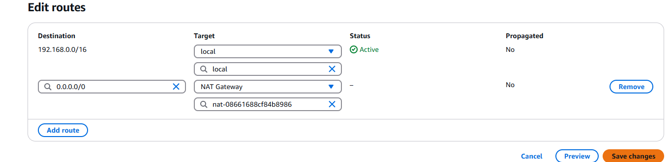

STEP 4: Create a RDS MYSQL database in private subnet which will act as a Database tier which manages and stores the information of the application.
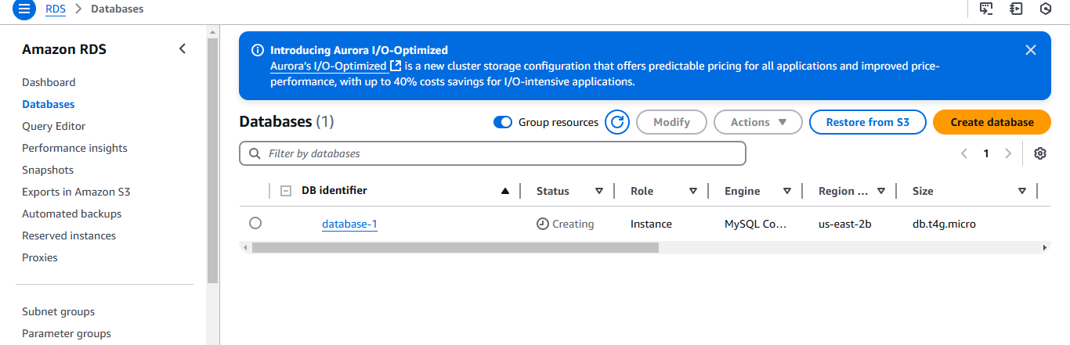

STEP 5 : Create a Bastion EC2 instance in public subnet and private EC2 instance in private subnet . The application code will be in private ec2 instance. Bastion EC2 instance has been used to access Private EC2 instance in private subnet.
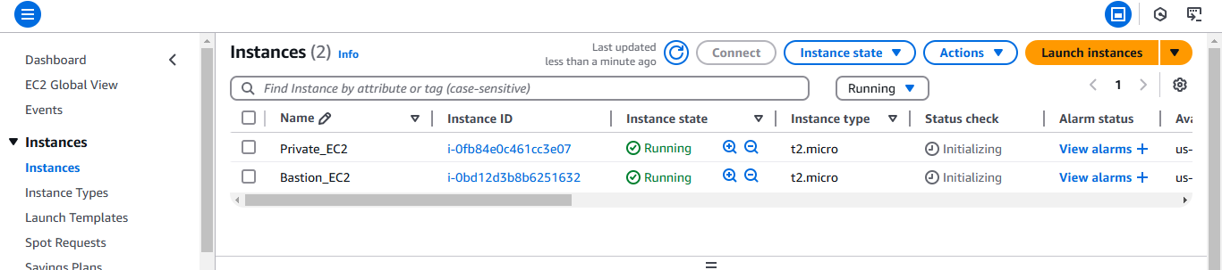

STEP 6: Log in to the public EC2 instance through putty and by using key pair of private EC2 instance we will be able to access Private EC2 instance.
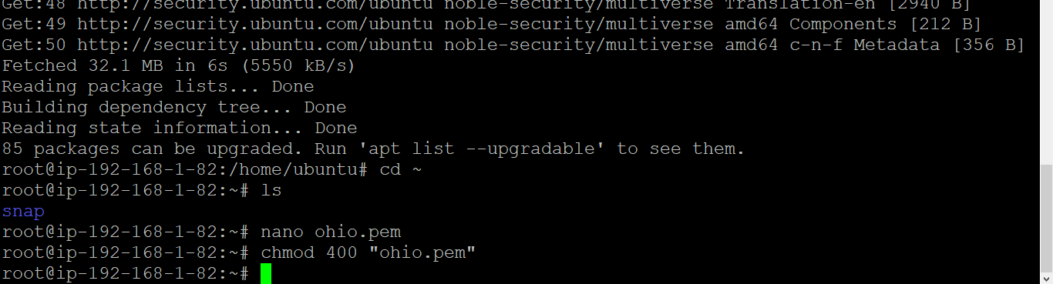

STEP 7: Clone the Git repository where project code is present and edit the application.properties file with the database credentials which we have created earlier.
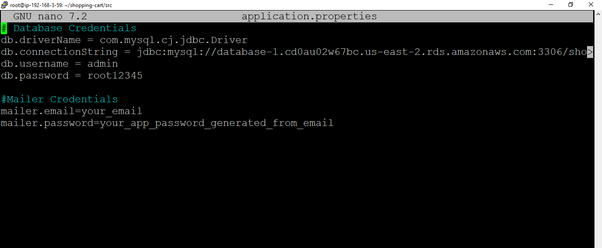

STEP 8: Install Apache tomcat in Private EC2 instance which will used to deploy application. Below are the commands for tomcat installation.
sudo apt update

sudo apt install default-jdk -y

sudo mkdir -p /opt/tomcat

sudo groupadd tomcat

sudo useradd -s /bin/false -g tomcat -d /opt/tomcat tomcat

wget https://archive.apache.org/dist/tomcat/tomcat-8/v8.5.88/bin/apache-tomcat-8.5.88.tar.gz

sudo tar xzvf apache-tomcat-8.5.88.tar.gz -C /opt/tomcat --strip-components=1

sudo chown -RH tomcat: /opt/tomcat

sudo sh -c 'chmod +x /opt/tomcat/bin/*.sh'

sudo update-java-alternatives -l

sudo nano /etc/systemd/system/tomcat.service

[Unit]
Description=Apache Tomcat Web Application Container
After=network.target
[Service]
Type=forking
User=tomcat
Group=tomcat
Environment="JAVA_HOME=/usr/lib/jvm/java-1.21.0-openjdk-amd64"
Environment="CATALINA_BASE=/opt/tomcat"
Environment="CATALINA_HOME=/opt/tomcat"
Environment="CATALINA_PID=/opt/tomcat/temp/tomcat.pid"
Environment="JAVA_OPTS=-Djava.security.egd=file:///dev/urandom -Djava.awt.headless=true"
Environment="CATALINA_OPTS=-Xms512M -Xmx1024M -server -XX:+UseParallelGC"
ExecStart=/opt/tomcat/bin/startup.sh
ExecStop=/opt/tomcat/bin/shutdown.sh
[Install]
WantedBy=multi-user.target

sudo systemctl daemon-reload
sudo systemctl start tomcat
sudo systemctl enable tomcat

sudo vi /opt/tomcat/conf/tomcat-users.xml

<tomcat-users>
<role rolename="manager-gui"/>
<user username="tomcatmgr" password="tomcatmgr" roles="manager-gui"/>
</tomcat-users>

sudo systemctl restart tomcat

cd /opt/tomcat/conf/Catalina/localhost

nano manager.xml

<Context privileged="true" antiResourceLocking="false"
docBase="${catalina.home}/webapps/manager">
<Valve className="org.apache.catalina.valves.RemoteAddrValve" allow="^.*$" />
</Context>

#!/bin/bash
sudo systemctl daemon-reload
sudo systemctl start tomcat
sudo systemctl enable tomcat

STEP 9: By using mvn clean package command in the project repository , maven will transform the project code into executable war file format as given in below slide.
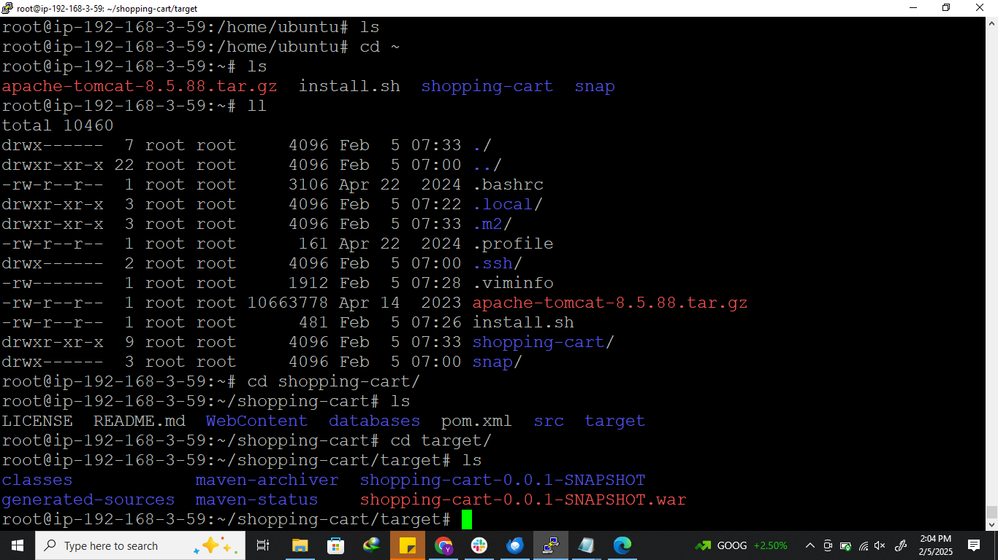

STEP 10: Create an Application load balancer with target group and register the Private EC2 instance to which ALB will distribute the traffic.
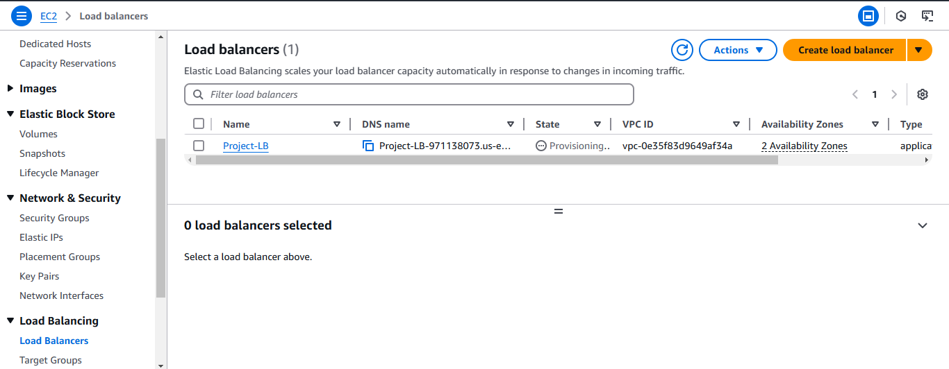

STEP 11: Connect to RDS database by using the Endpoint of Database and login credentials with the following command.
mysql -h database-1.cd0au02w67bc.us-east-2.rds.amazonaws.com -u admin -p root12345
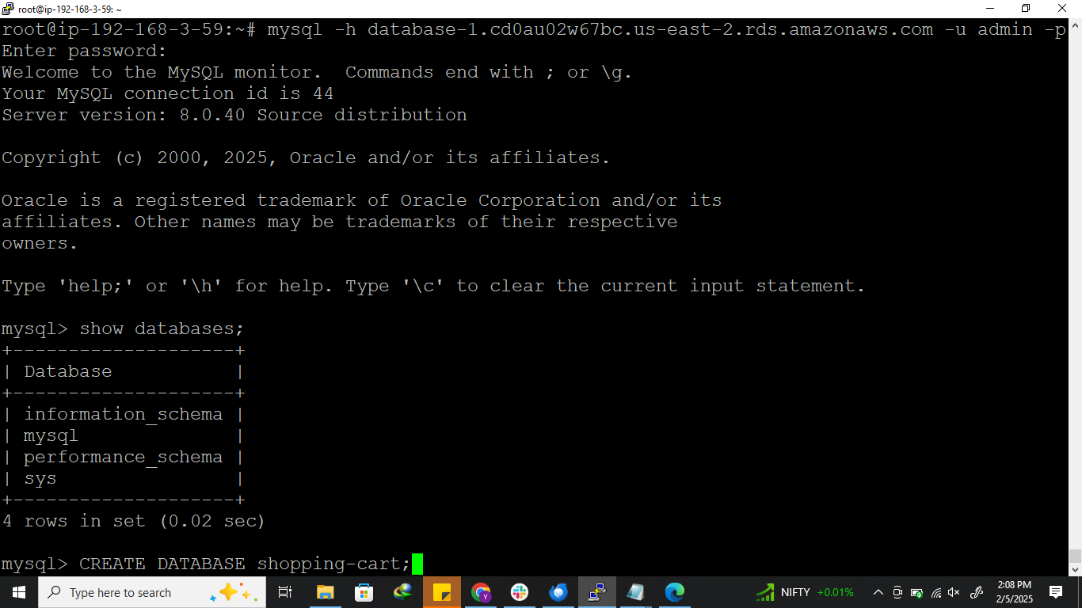

STEP 12: Copy the appliction war file to the /opt/tomcat/webapps path and By using the DNS name of load balancer we will be able to access the Apache Tomcat homepage where the application has been deployed .
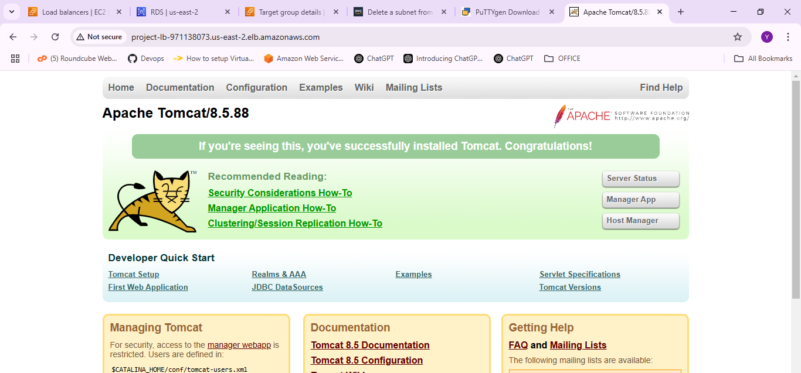

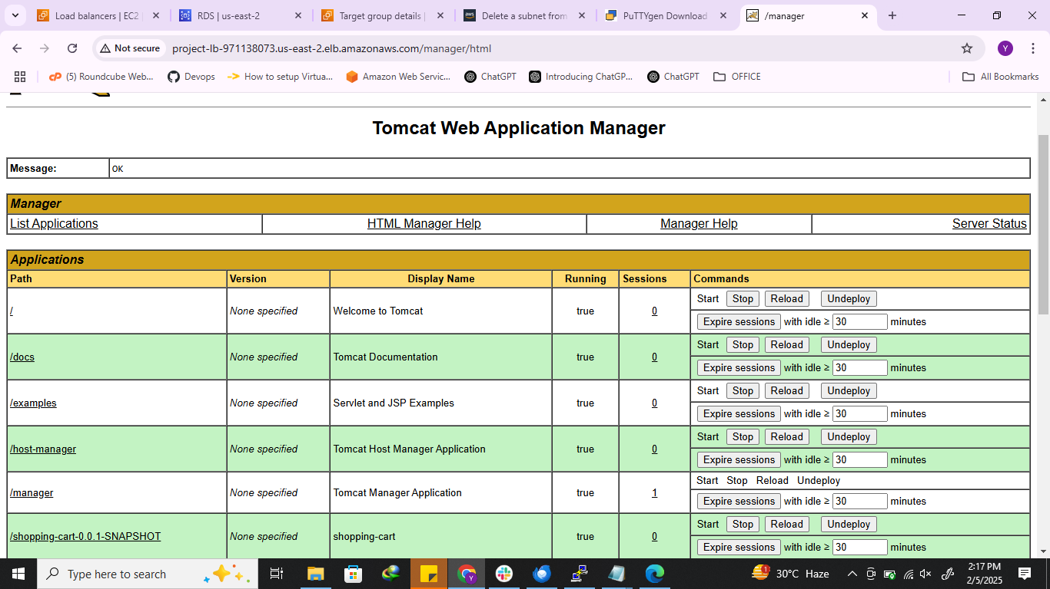
STEP 13: By clicking on application we will be able to access the application on the browser.
